A FOOD SEARCHING APPLICATION

MOFO:  
PROJECT PLAN / PROPOSAL   
_______________________________________________________________________________________________________________________________________________________

BIT302 Software Engineering:  
Assignment 1  
  
**Author: B1402427 CHIN WEI QING  
Lecturer: MS. SEETHA**15 February 2016

**Contact Detail:** [**WEIQING.CHIN@GMAIL.COM**](mailto:WEIQING.CHIN@GMAIL.COM)

**Abstract**Where to and what to eat, is a daily problem faced by most Malaysia's youngster. And the solution to this problem? MoFo application. MoFo was designed to eliminate the process of thinking where to and what to eat by suggesting food and beverage outlets to the user.   
  
Application will be created by Java and are to be run on any android devices with version 4.4.2 and above. Implemented using incremental model methodology with risk management in placed.

Contents

Title: MoFo 2

1.1 Project Introduction 2

1.2 Project Aim 2

1.3 Project Objectives 2

1.4 Project Scope 3

2.0 Resource Allocation 3

2.1 Minimal hardware & software requirement (Development Environment) 3

2.2 Minimum hardware & software requirements (Operations/Demo Environment) 4

2.3 Required Data and/or Information 4

3.0 Project Standards & Procedures 4

4.0 Milestones & Deliverables 5

5.0 Project Schedule – Gantt Chart 6

6.0 Planning 7

6.1 Quality Assurance Plan 7

6.2 Test Plan 7

6.3 Training Plan 7

6.4 Security Plan 7

6.5 Risk Management Plan 7

## 1.1 Project Introduction

This project aim to help Malaysian youngster to reduce the time spend, and speed up the process of thinking where to eat and what to eat.

## 1.2 Project Aim

The aim of the project is to enable the MoFo App User to greatly reduce the time taken to decide on where to eat as well as to introduce the MoFo App User to food and beverage outlets that the MoFo App User does not know about.

## 1.3 Project Objectives

Pobj – 1.0: To suggest food and beverage outlets to the MoFo App User.

Pobj – 2.0: To introduce new food and beverage outlets to the MoFo App User.

Pobj – 3.0: To allow food and beverage outlets to be more well known.

Pobj – 4.0: To allow the MoFo App User to bookmark food and beverage outlets for future references.

Pobj – 5.0: To allow the MoFo App User to provide feedback on the food and beverage outlets.

Pobj – 6.0: To allow the MoFo App User to know what other MoFo App Users think about the food and beverage outlets.

## 1.4 Project Scope

User will be able to set the search setting  
Food and beverage outlets availability result shown based on user setting and location.

Expanded detail of the outlet can be view by user.  
User are able to like the post to show the popularity of the food and beverage outlets.  
Post can be bookmark by user for later view.  
Bookmarked post will be save and to be view later on.

# 2.0 Resource Allocation

## 2.1 Minimal hardware & software requirement (Development Environment)

|  |  |
| --- | --- |
| Hardware | |
| Windows version | Window Vista and above (32-bit or 64-bit) |
| Processor | 1GHz Intel Pentium IV or equivalent |
| Installed memory (RAM) | 2GB RAM |
| Disk space | 1.5GB of free disk space |

|  |  |
| --- | --- |
| Software | |
| Java Development Kit 8(JDK) | java development environment |
| Android Software Development Kit (SDK) | android emulator |
| Ionic version 1.2.4 | create basic layout design |
| Android Studio version 5.1 | Android coding platform, android emulator |
| Ganttproject version 2.7.2 | draw gantt chart |
| DIA version 0.97.2 | create diagram, eg. ERD |
| PaintTool SAI version 1 | create and edit image of the application |
| XAMPP Control Panel version 1.3.0.10 | create server for data storing |

## 2.2 Minimum hardware & software requirements (Operations/Demo Environment)

|  |  |
| --- | --- |
| Software | |
| Device | Nexus S 480*800 |
| Target | Android 4.4.2 |
| CPU/ABI | ARM (armeabi-v7a) |
| RAM | 512 |

## 2.3 Required Data and/or Information

Information required such as types of cuisine accepted by and served in Malaysia, including the of food choice available and differentiate by Malaysian .Followed by a list of food and beverages outlets around popular area, with details such as name, address, operating hours, price tag, cuisine type, telephone no. and optional food picture. User’s geolocation is also required in order to track and display the food and beverage outlets around user.

# 3.0 Project Standards & Procedures

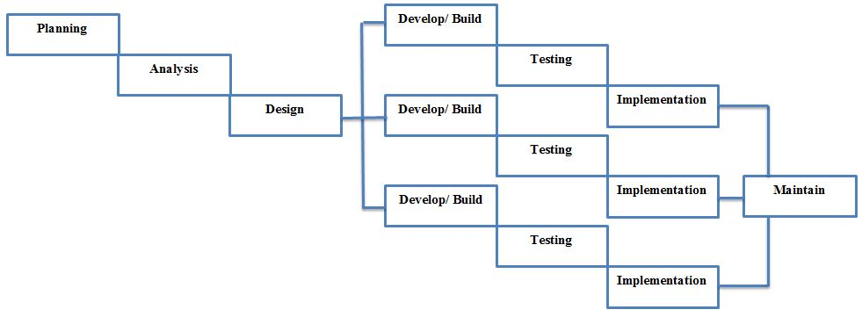

*Figure 1.0 Incremental Prototyping*

The chosen methodology for MoFo app is incremental prototyping model. The high flexibility of this adoption allow project to be divided into part. When develop by part, the modification process is simplified. Hence any changes can be made easily to match the proposed requirement. Developing by part also mean it ease process of identifying error. Thurs the chance of facing unknown error during development is greatly reduce. Besides, duration to complete each cycle is reduced, in result a faster functional deliverable.

# 4.0 Milestones & Deliverables

|  |  |  |
| --- | --- | --- |
| **Activities** | **Milestone/Deliverable** | **Date** |
| Planning | Approval of Project Plan | 18th January 2016 |
| Requirement Gathering and Analysis | Completion of Requirement Specification Document | 1st February 2016 |
| Design | Completion of Design Document | 14th February 2106 |
| Initial documentation | Initial Documentation complete | 14th February 2016 |
| Presentation | First Presentation | 22 February 2016 |
| Implementing | Prototype 1 | 1st March 2106 |
| Testing | Completion of testing Prototype 1 | 2nd March 2106 |
| Implementing | Prototype 2 | 15th March 2106 |
| Testing | Completion of testing Prototype 2 | 18th March 2106 |
| Implementing | Prototype 3 | 2nd April 2016 |
| Testing | Completion of Prototype 3 Testing | 4th April 2016 |
| Final Testing | Completion of Overall Testing | 7th April 2016 |
| Final Documentation | Completion of Overall Documentation | 10th April 2016 |
| Final Presentation | Completion of Presentation | 11th April 2016 |

# 5.0 Project Schedule – Gantt Chart **F:\asssssssssssssssssssssss\Assignment 1\done\Gantt Chart.jpg**

*Figure 2.0 Gantt Chart*

# 6.0 Planning

## 6.1 Quality Assurance Plan

To assure the quality of the application, a weekly basis assessment will be carry out to check if the project meet the requirement specification, and to ensure everything work according to the project schedule. In addition, guidance will be presented by external parties in the event of progression halt due to stuck in coding.

## 6.2 Test Plan

To identify error and check with the consistency between implementation and requirement, the code will be tested at every phase of milestone. This is to ensure every bits of code is bug free and each function is workable.

Upon completion, there will be two phase of checking, where parts of function are tests together as one, and the whole system to be tested as another. the compatibility between functions is first tested, and to ease any bug finding process between functions. The following test is to see if it works on devices as a whole.

## 6.3 Training Plan

As a student without the advance knowledge of Java development, training is must. Objectives of daily study plus a weekly exercise for up to one month duration are to be carried out consecutively between developments.

## 6.4 Security Plan

All user information is confidential and will be stored on secure database. User information consists of registration detail, such as userID, password, and email.

## 6.5 Risk Management Plan

|  |  |  |  |  |
| --- | --- | --- | --- | --- |
| **#** | **Description** | **Probability %** | **Impact 1= low 5=high** | **Mitigation Strategy** |
| 1 | lack of knowledge in coding | 80 | 5 | Changing of development platform. Potential alternative is HTML. |
| 2 | Application does not work | 60 | 5 | Check or rewrite the code again. |
| 3 | Application fail to develop in time | 50 | 3 | Develop without postposed; and constantly check progress with gantt chart. If delayed occur, increase working hours. |
| 4 | Application unable to track user location | 30 | 3 | Check and compare code with the geolocation API again. |
| 5 | Application unable to retrieve information from database | 40 | 5 | Check the code again, search internet for similar error solution. |
| 6 | Application fail to bookmark post | 20 | 2 | Check or rewrite the code again. |

A FOOD SEARCHING APPLICATION

MOFO:  
REQUIREMENT DEFINITION AND SPECIFICATION DOCUMENT  
_______________________________________________________________________________________________________________________________________________________

BIT302 Software Engineering:  
Assignment 1  
  
**Author: B1402427 CHIN WEI QING  
Lecturer: MS. SEETHA**15 February 2016

**Contact Detail:** [**WEIQING.CHIN@GMAIL.COM**](mailto:WEIQING.CHIN@GMAIL.COM)

# Abstract/Executive Summary

MoFo aim to ease user from the daily process of thinking what or where to eat. The application is use to suggest food and beverages outlets available around the user. Base on user’s setting and GPS location, MoFo application analyse what might interest the user and suggest what’s best yet available around them. User can then review the post to show the outlets popularity, or bookmark interested outlet for further reference.

# Table of Contents

1. Background 1
2. Objective Of the New Application 1
3. Software Specification 1
   1. Functional Requirement 1
   2. Non-Functional Requirement 3
   3. Constraints 4
4. Requirement Specification 5

4.1 Expended Use Case 5

* + 1. Expended Use Case – Create Account 5
    2. Expended Use Case – Login Account 5
    3. Expended Use Case – Adjust Search Setting 6
    4. Expended Use Case – View Post 7
    5. Expended Use Case – View Post Information 8
    6. Expended Use Case – Review Post 9
    7. Expended Use Case – Bookmark Post 9
    8. Expended Use Case – View Bookmark 10
  1. Use Case Diagram 12
  2. Analysis Class Diagram 12
  3. Sequence Diagram 13
     1. Sequence Diagram 1 (Create Account) 14
     2. Sequence Diagram 2 (Login Account) 14
     3. Sequence Diagram 3 (Adjust Search Setting) 15
     4. Sequence Diagram 4 ( View Post) 16
     5. Sequence Diagram 5 (View Post Information) 17
     6. Sequence Diagram 6 ( Review Post) 18
     7. Sequence Diagram 7 (Bookmark Post) 19
     8. Sequence Diagram 8 (View Bookmark) 19
  4. Design Class Diagram 20

# 1.0 Background

As a university student, we tend to kill time between classes by eating out. Yet the process of thinking where to eat is always tedious and a waste of time. To eliminate the process of thinking where to eat, we aim to develop an application to speed things up by suggesting the food and beverages outlets that might interest the user the best.

# 2.0 Objective of the New Application

Obj - 1.0: Reduce time spent on thinking where to eat  
Obj - 2.0: suggest best fit food and beverages outlets to user  
Obj - 3.0: give user a new insight of what’s offered around them  
Obj - 4.0: offer detail about the food and beverages outlets  
Obj - 5.0; bookmark interested food and beverages outlets for future reference

# 3.0 Software Specification

## 3.1 Functional Requirement

|  |  |
| --- | --- |
| Use Case | Create Account |
| Actor(s) | MoFo App User |
| Description | MoFo App User select create account in the application and fill up the form to create account. |

|  |  |
| --- | --- |
| Use Case | Login Account |
| Actor(s) | MoFo App User |
| Description | MoFo App User log into MoFo account to start searching. |

|  |  |
| --- | --- |
| Use Case | Adjust Search Results |
| Actor(s) | MoFo App User |
| Description | MoFo App User input desired setting and the system retrieves and displays the matched post. |

|  |  |
| --- | --- |
| Use Case | View Post |
| Actor(s) | MoFo App User |
| Description | MoFo App User tap view post button on the screen. The system then retrieves and displays the next post. |

|  |  |
| --- | --- |
| Use Case | View Post Information |
| Actor(s) | MoFo App User |
| Description | MoFo App User select the desired post and the system retrieves and displays the post information. |

|  |  |
| --- | --- |
| Use Case | Review Post |
| Actor(s) | MoFo App User |
| Description | MoFo App User tap the like button to like the post. Post’s like count increase by one. |

|  |  |
| --- | --- |
| Use Case | Bookmark Post |
| Actor(s) | MoFo App User |
| Description | MoFo App User select the desired post and the system retrieves and bookmark the post. |

|  |  |
| --- | --- |
| Use Case | View Bookmarks |
| Actor(s) | MoFo App User |
| Description | MoFo App User scroll through the list of bookmarked post. Upon selected, the system retrieves and display the bookmarked post details. |

## 3.2 Non-Functional Requirement

* **Usability**-User friendly interface:   
  Standard Graphic User Interface with common icons and layout that are similar to other application. Reduce user’s application learning curve and increase adaptability. Minimal input, only registration & login require keyboard input.

-Organized output data:   
Consistent font, font colour, format. Font sizes vary by importance. Important font are bigger and bolded. Similar interface have same icon position.

* **Reliability**  
  -real time data to show the outlets availability.  
  -Bookmark is retrievable upon request.  
  -No up limit for bookmarking food and beverages outlets post.
* **Performance**-Retrieve user location automatically when devices GPS location is on.  
  -Able to display food and beverages outlets around user location that match the set range.  
  -Respond time:  
  Application opened within 2 seconds of lunch. Retrieving and displaying food and beverages outlets to be done within 10 seconds on optimum internet connection. Any other action within the app should respond within 2 seconds upon press.
* **Availability**-24/7 uptime server and backup server to achieve 100% availability
* **Security**-User id and password is private and confidential, by no mean will this be shared.  
  -User current location is private and confidential, and will not be shared or used without user permission.
* **Capability**  
  -regional limitation: Currently available in Malaysia city area only.  
  -outlets limitation: Food and beverage outlet displayed are limited Mofo database)  
  -outlet detail limitation: For example, phone no. and operating hours might not be available

## 3.3 Constraints

* **Performance constraints for the functions** As a newly develop application, it’s hard to control the battery and ram usage as the code will not be optimize. Furthermore, the required GPS will drain the usage of the devices even more due to the need to get the accurate location of the user. less to say it might not be bug free.

MoFo application has a high dependency on internet and GPS signal strength and availability. Unstable internet or GPS mean malfunction of the application.

User’s registration and login are limited, and only to MoFo application registration. This is highly inconvenience to user who expects Facebook or other social media login function.

Although GPS location is retrieve from the user, there is no link to Google Map application. The coordinate retrieved will be used for a sole purpose, which is search and display the food and beverage outlets within the user set range. Route to the outlets will not be available through MoFo application.

Simplifying the app usage by reducing user location input also mean user are not able to search for outlets at any other desired location. Users are only able to search for a particular location through the app if they are around the area.

* **Other related constraints for the functions** MoFo Application will be build based on android platform. The lack of iOS and Windows implementation mean non-android user are not able to access this application on their devices.

# 4.0 Requirements Specification

## 4.1 Expended Use Case

### 4.1.1 Expended Use Case – Create Account

|  |  |  |
| --- | --- | --- |
| ***Use Case 1*** | Create Account | |
| ***Goal in Context*** | To create a new MoFo account. | |
| ***Primary Actor******Secondary Actor*** | MoFo App User  (none) | |
| ***Trigger*** | When the MoFo App User wants to create a new MoFo App account. | |
| ***Related Use Cases*** |  | |
| ***Typical Course of Events******Actor Action*** | | **System Response** |
| 1. This use case begins when the MoFo App User wants to create a new MoFo account. | |  |
| 2. The MoFo App User enters the userID , password, email. | | The system saves the MoFo App User’s userID, password and email. A pop up message “ID created” and login window will be display. |
| ***Alternative Course of Events*** | | |
| Line 2a. If the userID already exist, a pop up message “ID already exists” is shown. | | |

### 4.1.2 Expended Use Case – Login Account

|  |  |  |
| --- | --- | --- |
| ***Use Case 2*** | Login Account | |
| ***Goal in Context*** | To log into MoFo application. | |
| ***Primary Actor******Secondary Actor*** | MoFo App User  (none) | |
| ***Trigger*** | When the MoFo App User wants to log into MoFo App account. | |
| ***Related Use Cases*** |  | |
| ***Typical Course of Events******Actor Action*** | | **System Response** |
| 1. This use case begins when the MoFo App User wants to log into MoFo account. | |  |
| 2. The MoFo App User enters the userID , password | | The system check the MoFo App User’s userID, password and the setting window will be displayed. User’s current location is retrieved through system’s GPS. |
| ***Alternative Course of Events*** | | |
| Line 2a. If the userID or password is wrong, the system will display “login error”. | | |
| Line 2b if the GPS is not turn on, system will prompt user to turn on the GPS. | | |

### 4.1.3 Expended Use Case – Adjust Search Setting

|  |  |  |
| --- | --- | --- |
| ***Use Case 3*** | Adjust Search Results | |
| ***Goal in Context*** | To adjust the search results of the food and beverage outlets or activities. | |
| ***Primary Actor******Secondary Actor*** | MoFo User  (none) | |
| ***Trigger*** | When the MoFo App User wants to narrow down the search results. | |
| ***Related Use Cases*** | (none) | |
| ***Typical Course of Events******Actor Action*** | | **System Response** |
| 1. This use case begins when the MoFo App User wants to narrow down the search results. | |  |
| 2. The MoFo App User selects the price, distance, operating hours, category, and details. | | The system displays posts that matches the price, distance, opearatingHours, category,and details entered by the MoFo User. |
| ***Alternative Course of Events*** | | |
| Line 3a. If there is no result that matches the category, location, distance and operating hours entered by the MoFo App User, a message “no results found, try altering search setting” is displayed. | | |

### 4.1.4 Expended Use Case – View Post

|  |  |  |
| --- | --- | --- |
| ***Use Case 4*** | View Post | |
| ***Goal in Context*** | To view the post that matches the user search setting. | |
| ***Primary Actor******Secondary Actor*** | MoFo App User  (none) | |
| ***Trigger*** | When the MoFo App User wants to view a post that is in the MoFo App. | |
| ***Related Use Cases*** | (none) | |
| ***Typical Course of Events******Actor Action*** | | **System Response** |
| 1. This use case begins when the MoFo App User wants to view a post that is in the app. | |  |
| 2. The MoFo App User click the next post button on the screen to view next posts. | | The system displays the posts that match user search setting. |
| ***Alternative Course of Events*** | | |
|  | | |

### 4.1.5 Expended Use Case – View Post Information

|  |  |  |
| --- | --- | --- |
| ***Use Case 5*** | View Post Information | |
| ***Goal in Context*** | To view the information of the food and beverages outlet post. | |
| ***Primary Actor******Secondary Actor*** | MoFo App User  (none) | |
| ***Trigger*** | When the MoFo App User wants to view the information of the food and beverages outlet post. | |
| ***Related Use Cases*** | (none) | |
| ***Typical Course of Events******Actor Action*** | | **System Response** |
| 1. This use case begins when the MoFo App User wants to view the information of the food and beverages outlet post. | |  |
| 2. The MoFo App User tap the post to view the information of the post. | | The system retrieve the postID and display the post information, which consist of title, description, category, price, operatingHours, address and phoneNo.. |
| ***Alternative Course of Events*** | | |
|  | | |

### 4.1.6 Expended Use Case – Review Post

|  |  |  |
| --- | --- | --- |
| ***Use Case 6*** | Review Post | |
| ***Goal in Context*** | To provide a feedback regarding a post. | |
| ***Primary Actor******Secondary Actor*** | MoFo User  (none) | |
| ***Trigger*** | When the MoFo App User wants to provide a feedback regarding a post. | |
| ***Related Use Cases*** | (none) | |
| ***Typical Course of Events******Actor Action*** | | **System Response** |
| 1.      This use case begins when the MoFo User wants to provide a feedback regarding a post. | |  |
| 2.    The MoFo App User tap the like button to like the post. | | The system retrieves the postID based on the MoFo App User input and update the post’s like count. |
| ***Alternative Course of Events*** | | |
| Line 4. The MoFo App User does not select the like button if the User is not satisfied with the post. | | |

### 4.1.7 Expended Use Case – Bookmark Post

|  |  |  |
| --- | --- | --- |
| ***Use Case 7*** | Bookmark Post | |
| ***Goal in Context*** | To bookmark a food and beverages outlet post for future reference. | |
| ***Primary Actor******Secondary Actor*** | MoFo App User  (none) | |
| ***Trigger*** | When the MoFo App User wants to bookmark a food and beverages outlet post for future reference. | |
| ***Related Use Cases*** | (none) | |
| ***Typical Course of Events******Actor Action*** | | **System Response** |
| 1. This use case begins when the MoFo App User wants to bookmark a food and beverages outlet post for future reference. | |  |
| 2. The MoFo App User press the bookmark button to bookmark the post. | | postID is retrieve and added to Bookmarks. |
| ***Alternative Course of Events*** | | |
|  | | |

### 4.1.8 Expended Use Case – View Bookmark

|  |  |  |
| --- | --- | --- |
| ***Use Case 8*** | View Bookmarks | |
| ***Goal in Context*** | To view the posts that have been bookmarked by the MoFo App User. | |
| ***Primary Actor******Secondary Actor*** | MoFo App User  (none) | |
| ***Trigger*** | When the MoFo App User wants to view the bookmarked posts. | |
| ***Related Use Cases*** | (none) | |
| ***Typical Course of Events******Actor Action*** | | **System Response** |
| 1. This use case begins when the MoFo App User wants to view the bookmarked posts. | |  |
| 2. The MoFo App User scrolls through the list of bookmarked posts. | | The system displays a list of posts that have been bookmarked by the MoFo App User. |
| 3. The MoFo App User selects the post by tapping on the post he wishes to view. | | The system retrieve post base on MoFo App User Input. |
| ***Alternative Course of Events*** | | |
| Line 3. If there is no bookmarked post, a message “no bookmarked post yet!” is displayed. | | |

## 4.2 Use Case Diagram

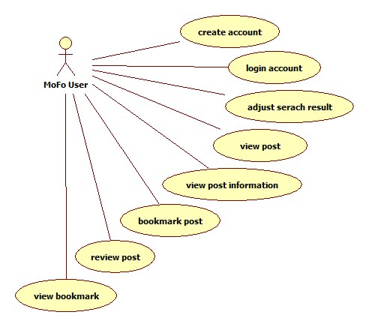

*Figure 1.0 Use Case Diagram*

## 4.3 Analysis Class Diagram

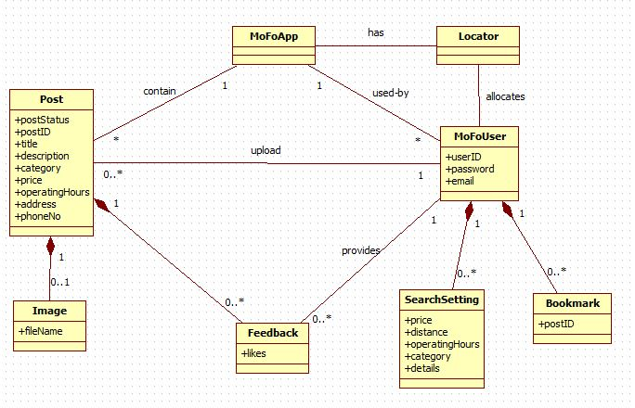*Figure 2.0 Analysis Class Diagrams*

## 4.4 Sequence Diagram

### Sequence Diagram 1 ( Create Account )

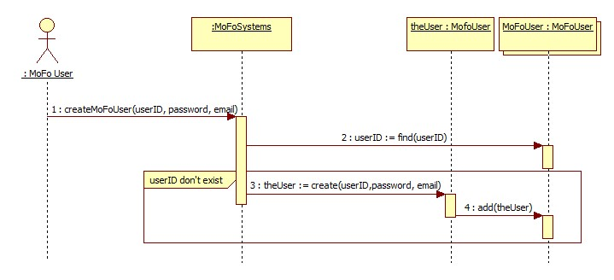

*Sequence Diagram 1*

### Sequence Diagram 2 ( Login Account )

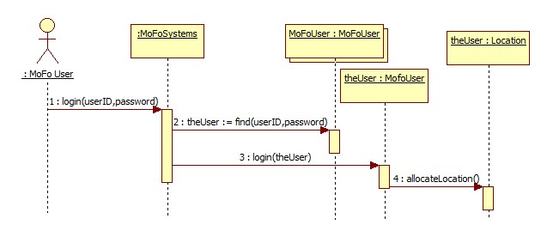

*Sequence Diagram 2*

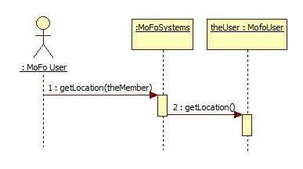

*Sequence Diagram 2.1*

### Sequence Diagram 3 ( Adjust Search Setting )

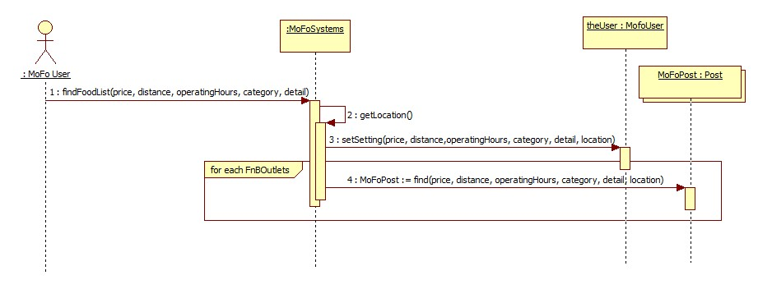

*Sequence Diagram 3*

### Sequence Diagram 4 ( View Post )

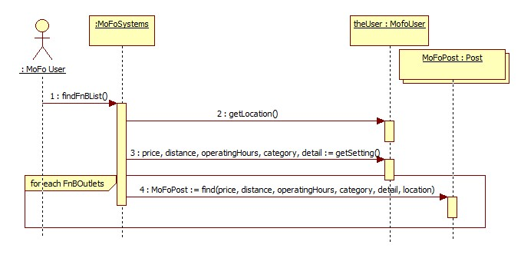

*Sequence Diagram 4*

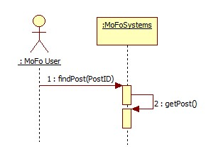

*Sequence Diagram 4.1*

### Sequence Diagram 5 ( View Post Information )

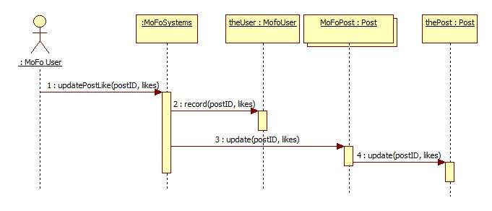

*Sequence Diagram 5*

### Sequence Diagram 6 ( Review Post )

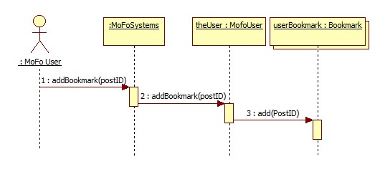

*Sequence Diagram 6*

### Sequence Diagram 7 ( Bookmark Post )

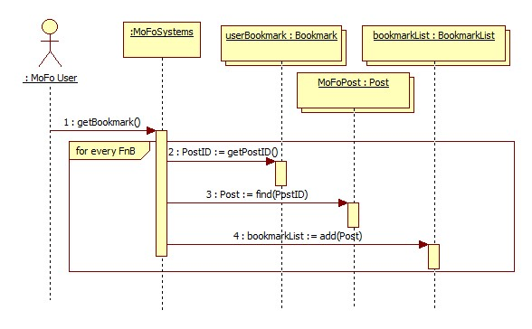

*Sequence Diagram 7*

### Sequence Diagram 8 ( View Bookmark )

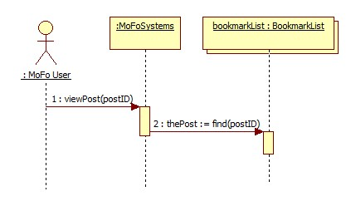

*Sequence Diagram 8*

## 4.5 Design Class Diagram

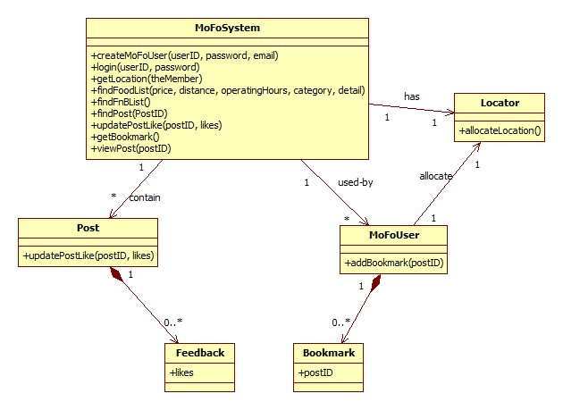

*Figure 3.0 Design Class Diagram*

A FOOD SEARCHING APPLICATION

MOFO:  
DESIGN SPECIFICATION DOCUMENT  
_______________________________________________________________________________________________________________________________________________________

BIT302 Software Engineering:  
Assignment 1  
  
**Author: B1402427 CHIN WEI QING  
Lecturer: MS. SEETHA**15 February 2016

**Contact Detail:** [**WEIQING.CHIN@GMAIL.COM**](mailto:WEIQING.CHIN@GMAIL.COM)

# Abstract/Executive Summary

At Mofo, we aim to deliver the simplest yet user friendly interface. This mean it's self-explanatory and even novice can understand how to work around it. Mofo application design is based on principle of user interface, which cover a few common rules, consistency, conserver attention, and simplicity. To emphasize the importance of the item on the window, placement of each item should be consider wisely; as well as the use of topography, can help to direct the attention to the key feature. To reduce hassle, the only text field input required are registration and login; While the rest of the input are made up of toggles, slider, labelled button. On the other hand, the navigation components are only made up of slider, icon and button. The menu panel, located at the left-hand side of the application, covers the home, setting and bookmarked shortcut, In the home window, user can view next post, bookmark or like the post. Labelled button provided for user to view more information about the post. In the setting window, user can toggle or slider button to adjust the search setting. Bookmarked post will be saved in bookmark window, where users are able to check for more information later on. SQL are used for coding and setting a server and database. MoFo app transition follows the common user interface design.

# Table of Contents

1.0 Overall System Architecture 1  
2.0 Detailed Design 1  
2.1Data Design 1  
 2.1.1 Site Map 3  
 2.1.2 Entity Relationship Diagram 3  
 2.1.3 Attribute Table 4

# 1.0 Overall System Architecture

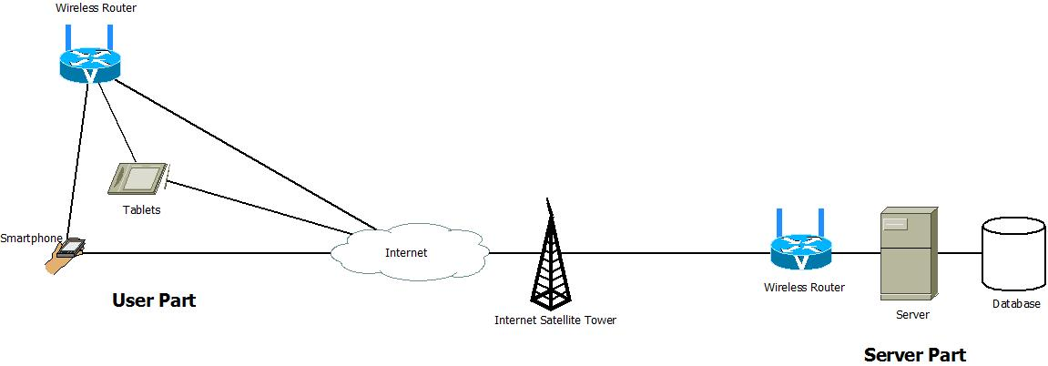

*Figure 1.0 Deployment Diagram*

The diagram is made up of two key components. First, the user parts consist of user’s devices, where their current location are retrieved and sent through the internet to the server. The storage part, consist of a server and a database server to store user data and the food and beverages outlets data. To search with MoFo Application, user is required to register an account beforehand. User accounts are required so that user can bookmark favourite post.

The diagram provide real-time environment system, where time are recorded, so user will know if the outlets is open at that particular moment.

# 2.0 Detailed Design

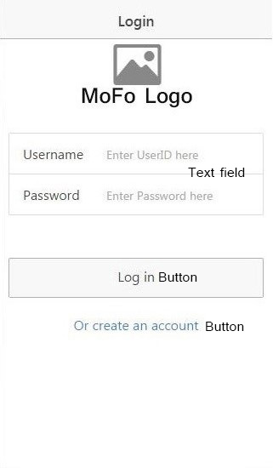 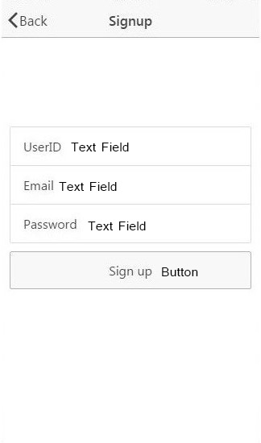 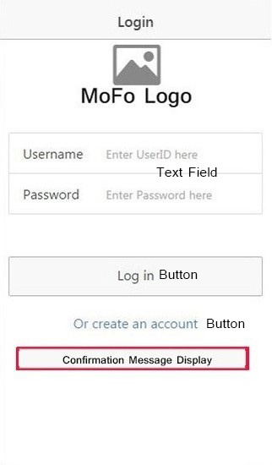

*Figure 2.1 - Sketch 1 Figure 2.2 - Sketch 2 Figure 2.3 - Sketch 3*

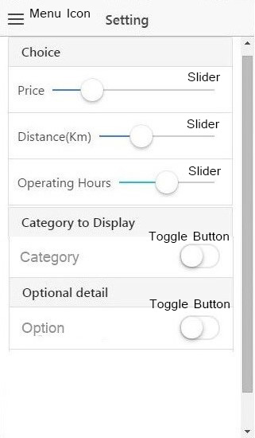 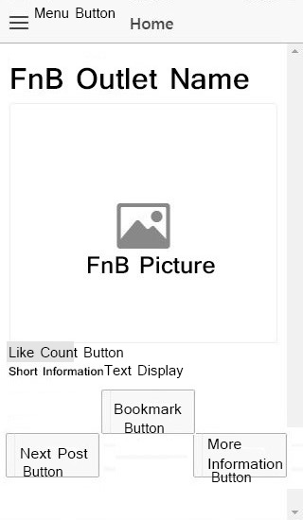 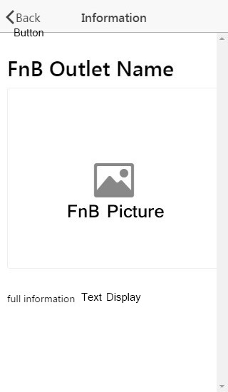

*Figure 2.4 - Sketch 4 Figure 2.5- Sketch 5 Figure 2.6 - Sketch 6*

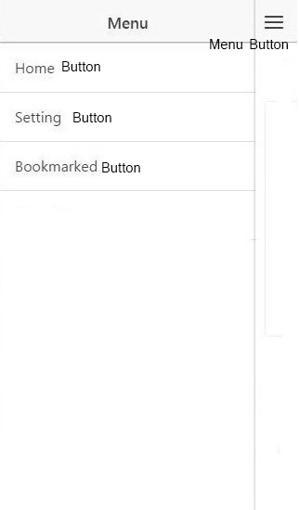 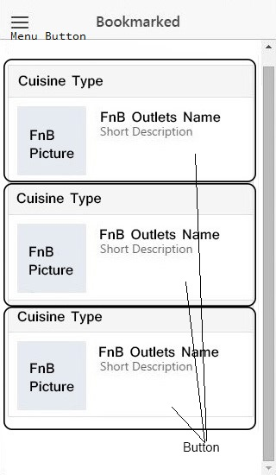

*Figure 2.7 - Sketch 7 Figure 2.8 - Sketch 8*

In order for user to adapt to Mofo App, the interface is consistent and predictable. To further enhance it, the background will be in mono colour. The contrast helps the app to look elegant yet simple, so that every detail and aspect can stand out clearly. The Home’s Post Information UI will have the same as bookmark’s Information UI. (*Figure2.1)* show the login window where *(Figure 2.2*) show the create account window, (*Figure2.3)* is what happen when create account success. After login, the Setting (*Figure 2.4)* will be display for user to set. Once user set the detail, post will be displayed (*Figure 2.5).* User can click more information and more information *(Figure2.6)* will be display. The side menu bar *(Figure2.7)* which user can have access to bookmark tab *(Figure2.8)*

## 2.1 Data Design

### 2.1.1 Site Map

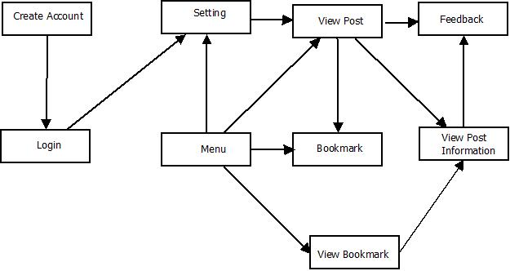

*Figure 2.1.1 Site Map*

### 2.1.2 Entity Relationship Diagram

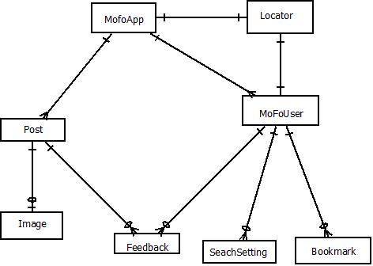

*Figure 2.1.2 ERD*

### 2.1.3 Attribute Table

|  |  |
| --- | --- |
| **Attribute** | **Data type** |
| postStatus | boolean |
| postID | varChar (10) |
| title | varChar (50) |
| description | varChar (100) |
| category | varChar (15) |
| price | float |
| operatingHours | float |
| address | varChar (100) |
| phoneNo | char (15) |
| fileName | varChar (30) |
| likes | integer |
| userID | varChar (15) |
| password | integer (15) |
| email | varChar (25) |
| details | varChar (25) |

# Individual Assessment

**Contribution (Chin Wei Qing B1402427)**

|  |  |  |
| --- | --- | --- |
| **Report** | **Problem faced** | **Solution to overcome** |
| Group meetings | Disputable idea | Online research for pre-existing idea. |
| Assignment partners | Teammate drop subject | Solo and round up idea from peers. |
| Project proposal | Insufficient resources | Peers consultation and online research. |
| Software and Hardware | Tools for developing | Search for online review, peers suggestion. |
| UML diagrams | Creating diagrams in StarUML | Notes and previous semester’s assignment referencing. |
| Report writing & documentation | Information and data writing | Generating idea through web information, and seek for past year paper reference. |
| Sketches and Work Structures | Interface of design | Online research for pre-existing application. |
| Coding | coding platform dilemma  Limited or no knowledge regarding certain programming language eg. SQL | Consult peer and friends for insight.  Analyse language available to be learn and use. |

# Appendix 1

# Bibliography

Fadeyev, D. (14 August , 2008). *Using Light, Color and Cntrast effectively in UI Design*. Retrieved 10 February, 2016, from usabilitypost: http://usabilitypost.com/2008/08/14/using-light-color-and-contrast-effectively-in-ui-design/

Martin, S. (August, 1993). *Effective Visual Communication for Graphical User Interfaces*. Retrieved 10 February, 2016, from Worcester Polytechnic Institute: http://web.cs.wpi.edu/~matt/courses/cs563/talks/smartin/int_design.html

*User Interface Design Basics*. (n.d.). Retrieved 10 February, 2016, from Usability.gov: http://www.usability.gov/what-and-why/user-interface-design.html

# Appendix 2

## Requirements Traceability Matrix

|  |  |  |  |  |  |
| --- | --- | --- | --- | --- | --- |
| **Requirement** | **In Design Specification** | **In Code** | **In Test Plan** | **In Implementation Plan** | **Notes** |
| 1.1 Registration | Figure 2.1 |  |  |  |  |
| 1.2 Login | Figure 2.2 |  |  |  |  |
| 1.3 Adjust Setting | Figure 2.3 |  |  |  |  |
| 1.4 View Post | Figure 2.4 |  |  |  |  |
| 1.5 View Post Information | Figure 2.5 |  |  |  |  |
| 1.6 Review Post | Figure 2.6 |  |  |  |  |
| 1.7 Bookmark Post | Figure 2.7 |  |  |  |  |
| 1.8 View Bookmark | Figure 2.8 |  |  |  |  |